Title: Groundwater well installation protocol

Author: Nick Ward Date: March 2020

Edited by: Evan Phillips & Anya Hopple Date of last revision: March 11, 2021

1. **Contents:**
2. Objectives
3. Experimental design
4. Installation materials
5. Personal protective equipment
6. Procedure
7. Corresponding documentation

VIII. References

**II. Objective:** To measure groundwater level and chemistry (DO, pH, EC, T, ORP) within each TEMPEST treatment plot. This protocol describes the groundwater well experimental design and installation procedure.

**III. Experimental design:** One groundwater well will be installed in a centralized grid square within each TEMPEST plot (Control = E4, Freshwater = F6, Seawater = F6). Groundwater wells are co-located with measurements of **(1)** soil temperature, volumetric water content, and electrical conductivity (continuous; installed at 5, 15, and 30 cm below the soil surface), **(2)** porewater chemistry (periodic; installed 15 cm below the soil surface), and **(3)** soil gas well nests (periodic; installed at 10, 20, 35, and 50 cm below the soil surface).

**IV. Installation materials:**

*Stage 1 – groundwater well construction:*

* 2” x 5’ well casings (up to 3 for each 5m well)
* 2” x 5’ well screen (1 for each 5m well)
* 2” PVC end caps
* PVC glue
* Well cleanout plugs
* Well sock
* Zipties
* Hacksaw or PVC cutter
* Drill with 1/8” and 1/4” bits
* Measuring tape

*Stage 2 – groundwater well installation:*

* Auger:
  + Ratcheting auger handle
  + 2 ¾” auger bit
  + 1m length auger extensions
  + Labelling tape
  + Sharpie/permanent marker
* 2 large crescent wrenches
* Screwdriver/spoon – for cleaning auger bucket
* Bins – for soil collection
* Tarps – for soil collection
* 50 lb sandbags (2 per well)
* Stake/rod for tamping sand
* Bentonite
* Freshwater for wetting bentonite
* Work gloves
* Measuring tape

Photos included in VII. Corresponding Documentation

**V. Personal protective equipment:** Close-toed shoes and long pants are required at all times when working at the TEMPEST site. Work gloves are also recommended for the installation portion of this protocol.

**VI. Procedure:**

*Stage 1 – groundwater well construction:*

1. One 2” x 5’ screened PVC section serves as the well bottom
2. Attach the screened PVC male threading to the female threading of one 2” x 5’ PVC casing. Add three 2” x 5’ PVC casing sections. The total well length = 20 ft
3. Use PVC glue to install a 2” PVC cap to the bottom of the screened section
4. Drill five 1/8” holes in the bottom cap
5. Use the PVC cutter to remove the male threading of the top PVC casing
6. Use PVC glue to install a cleanout plug to the top PVC casing
7. Drill a ¼” hole through the side and top of the cleanout plug
8. Add bolt (for hanging sensor) to the cleanout plug
9. Drill a 1/8” vent hole in the casing just underneath the cleanout plug
10. Place a filter sock over the screened PVC section with zipties
11. Measure total well length

*Stage 2 – groundwater well installation:*

1. Pre-label auger extensions with labeled tape at 10 cm intervals. The tape bottom = depth
2. Dig the hole using a 2 ¾” bucket auger and 1m extensions. Our goal is to get to depths that are consistently saturated with water, so if required, continue auguring deeper until the hole is ~1m below where water was first detected. Target depth = 5.25 m for all wells
3. Collect the soil in a bucket or bin for sampling (if collecting soil samples) and discard the excess soil onto a tarp for removal. This can be done by pushing the soil out with gloves, or a screwdriver to break up thicker soils and clay
4. Place a small amount of sand in the bottom of the hole (e.g. an inch or so, 3-4 scoops)
5. Place the groundwater well into the hole
6. Fill space around the well with sand until ~20 cm below the soil surface
7. If water table is high when installing, allow ~24 hours for sand to settle
8. Fill the remainder of the hole with bentonite, wetting it with water. Spread the bentonite around the perimeter of the well (e.g., a 4-6” diameter around the casing)
9. Measure all dimensions, e.g., total length of well, length from bottom of the well to the bolt, length of top of well to bolt, length of casing above the ground surface after installation.

*Stage 3 – groundwater well development:*

1. Use a peristaltic pump to drain the water out of the new wells. Do this several times if possible. If the well water is very muddy it can sometimes be useful to dump some freshwater into the well, then pump it back out.

**VII. Corresponding documentation:**

*Equipment reference photos:*

**

PVC cleanout plug

PVC endcap with holes

Auger Bucket

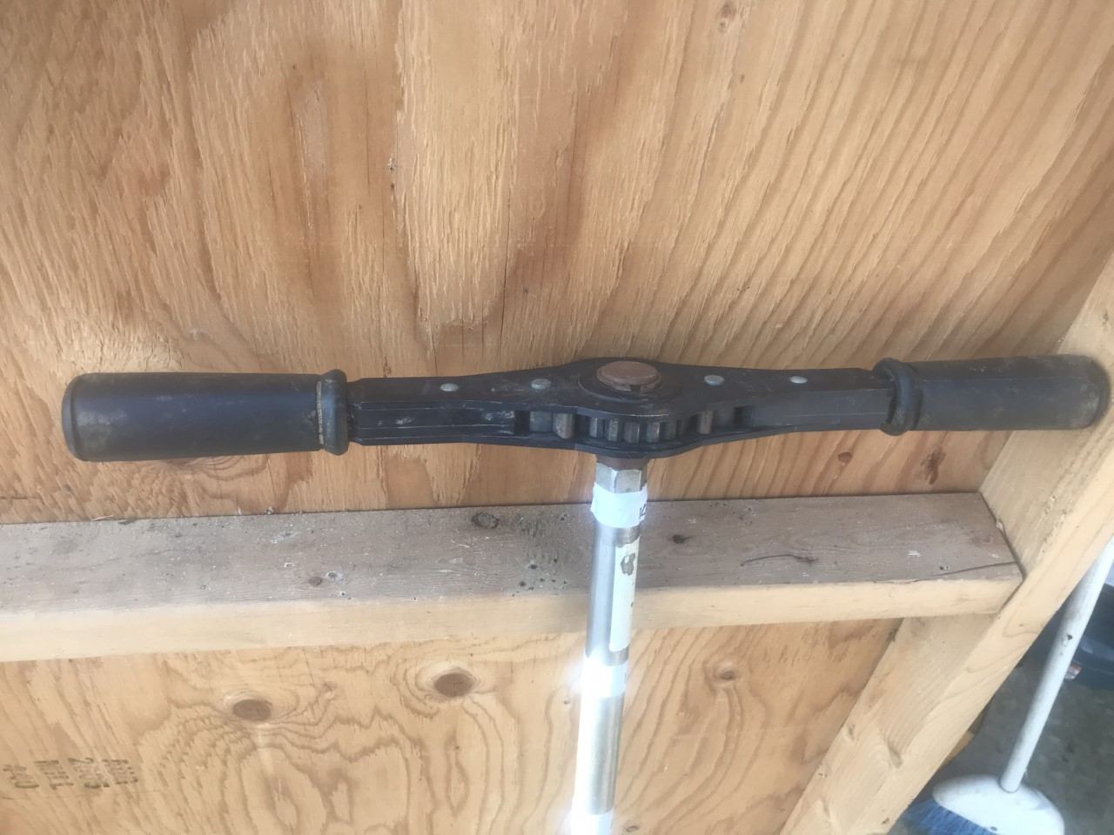

Ratcheting auger handle

Well sock

PVC screening

PVC casing

*Collection and processing photos*

1. **References:** N/A